Mobile Launch Rail
Field Procedures

FAR-001
Revision Draft

December 4, 2009
By: Mark Holthaus

Revision Status
Revision Letter | Date | Authority | Description
Draft | 12/04/2009 | M. Holthaus | Draft Release
Index
Reference Documents 4
Definition of Terms 5
1.0 Introduction 6
1.1 Description 6
Mobil Launch Rail Operating Hazards 12
Mobil Launch Rail Towing Preparation Procedure 15
Mobil Launch Rail Deployment Procedure 17
Mobil Launch Rail Stow Procedure 23
Mobil Launch Rail Return Procedure 26

Reference Documents
Document Number | Document Name
ATFP P 5400.7 | Federal Explosives Law and Regulations
 | LAWS AND REGULATIONS FOR TRANSPORTATION, USE AND STORAGE OF FIREWORKS IN CALIFORNIA (2008)

Definition of Terms
Term | Definition
2508CCF | R-2508 Central Coordinating Facility
AGL | Above Ground Level
BATFE | Bureau of Alcohol Tobacco, Firearms and Explosives
BLM | Bureau of Land Management
CSFM | California State Fire Marshal
FAA | Federal Aviation Administration
FAR | Friends of Amateur Rocketry, Inc.
MSL | Mean Sea Level
NOTAM | Notice to Airman
TRACON | Traffic Control, Edwards Air Force Base

1.0 Introduction
The following are the procedures for towing, deployment, stowing, and return of the Friends of Amateur Rocketry, Inc. Mobil Launch Rail.

Description
This Mobil Launch Rail has a 57-foot long tower with a 1-inch, T-rail on the top edge. See Figures 1 and 2. The launch rail comes in three pieces: one permanently attached to the trailer, and two detachable pieces. The launch rail can be assembled by two persons. This Mobil Launch Rail is designed to be towed to and from the launch site.

Initially, the launch rail is positioned and leveled. Four outriggers are removed from their storage place under the toolbox and inserted and locked into each of the trailers four corners. Leveling pads are inserted and pinned under each leveling jack. The leveling jacks are cranked down until the trailer is level from front-to-back and side-to-side. The center leveling jack is then cranked down until it is snug to the ground. Figure 3 shows the front rack that holds the center and outrigger leveling jack pads and sledge hammer. This rack locks the components in place when the spare tire cage is in the down position. Figure 4 shows the center leveling jack and the flame bucket. There are two clevises, one on each side, that hold the flame bucket up for transportation.

The rail is then assembled. The two segments are removed from their storage locations. The middle segment is fitted and bolted to the bottom segment. The upper is fitted and bolted to the middle segments. Figure 5 shows the launch rail guide pins and sockets. The three guide pins of an upper segment fit into the three sockets of the lower segment. The two segments are attached using four cap screws.

The guy wire assembly is attached and pinned to the upper rail segment. Figure 6 shows the guy wire assembly. The guy wire assembly fits into a socket and is pinned to the upper most rail segment. A tensioning cable is attached to the guy wire assembly and made snug by a turn buckle. The guy wires then hang from this assembly

Erecting the launch rail is accomplished using a battery operated hydraulic pump and actuator built in to the trailer. The trailer has a power selector switch that turns on the power and a detachable hand controller that commands the rail up and down. The trailer has a built in toolbox, battery operated water pump, water tank, and gas powered electrical generator. Positioning of the guy wires are shown in Figure 7. One guy wire is stretched out in the same direction of the trailer tongue. The other two guy wires are stretched out 120-degrees from the trailer tongue. Each guy wire is anchored with a stake and marked with a orange safety cone.

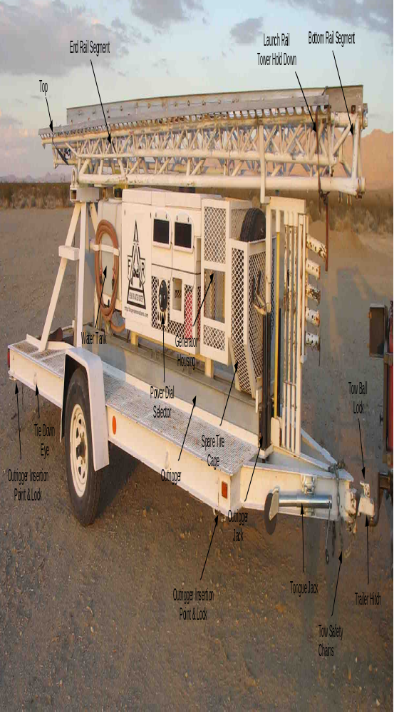
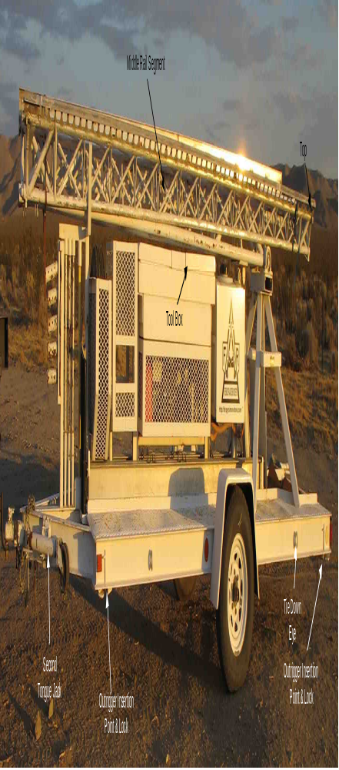

Mobil Launch Rail Operating Hazards
Hazard | Hazard Type | Description | Mitigation
Heavy Lifting | Back Injury | The outriggers weight approximately 40-lbs. | Use care in lifting.
Heavy Lifting | Back Injury | The spare tire basket weighs approximately 60-lbs. | Use two persons to lift.
Heavy Lifting | Back Injury | The flame deflector weighs approximately 60-lbs. | Use two persons to lift.
Lifting Overhead | Head and Back  Injury | The rail segments weigh approximately 40-lbs. and require lifting overhead. | Use two persons to lift.
Stake Pounding | Hand Injury | While pounding in the stakes, it may require someone to hold the stake while someone hits the stake with the sledgehammer. | Use care while holding stakes. Keep hands away from head of stake.
Electrocution | Death | Launch rail touching power lines while being raised. | Never raise the launch rail near power lines.
Crushing | Death and Property Damage | Rail falling over or buckling in high-winds. | Never raise the launch rail under high-winds.
Crushing | Death and Property Damage | Rail falling over or buckling when trailer is not level. | Never raise the launch rail when the trailer is not level.
Crushing | Death and Property Damage | Vehicles driving into guy wires causing the rail to fall over or buckle. | Place orange safety cones over stakes once pounded into the ground and take care in driving around guy wires with support vehicles
Crushing | Death and Property Damage | Rocket falls off of launch rail. | Have adequate rail guide brackets.
Crushing | Death and Property Damage | Rocket falls off of launch rail while raising and lowering. | Have adequate rail guide brackets. Place cradles under rocket, strap rocket to launch rail, and attach end holding bracket while raising and lowering. Have personnel steady the rocket.
Car Damage | Property Damage | Vehicle driving over the guy wire stakes. | Place orange safety cones over stakes once pounded into the ground.
Falling | Injury | Falling off trailer walk way while working on the rocket. | Use care while standing or walking on the trailer walk way.
Falling | Death | Falling off the launch rail. | Use caution while climbing on the launch rail.
Crashing | Death and Property Damage | Loss of vehicle control. | Have tow vehicle that is capable of handling the tongue weigh and towing capacity.
Crashing | Death and Property Damage | Loss of trailer control due to tire blow out. | Check tire condition.
Crashing | Death and Property Damage | Loss of trailer control due to trailer becoming detached from the tow vehicle. | Have safety chains connected to tow vehicle. Have trailer hitch mated properly and ball lock engaged, locked, and pinned.
Crashing | Death and Property Damage | Backing the trailer into someone, another vehicle, or other property. | Have adequate mirrors on the tow vehicle.
Crashing | Death and Property Damage | Being hitting by another vehicle. | Connect running and brake light connector and check that the lights are functioning.
Crashing | Death and Property Damage | Loss of launch rail segments while towing such that another vehicle is hit or runs over the rail segments. | Strap down the rail segments to the trailer before towing.

Mobil Launch Rail Towing Preparation Procedure
Step | Description
Check launch rail.
 | Check tire condition for cracks and worn tread.
 | Check tire pressure (approximately 60-psi).
 | Check spare tire pressure (approximately 60-psi).
 | Check for license plate firmly attached.
 | Check for equipment present using equipment list.
 | Check battery charge.
 | Check water tank level. (Optional)
 | Check generator oil level. (Optional)
 | Check generator gas level. (Optional)
 | Unlock security chain from trailer. (If applicable)
 | Relock security chain to anchor point.
Connect launch rail to the tow vehicle.
 | Crank the tongue jack up to lift trailer tongue high enough to clear of trailer hitch ball.
 | Back the tow vehicle up to the trailer.
 | Pull the pin from tow ball lock.
 | Lift lever on tow hitch lock.
 | Crank the tongue jack up to lower the trailer tongue on to the trailer hitch ball. Crack the tongue jack all the way up.
 | Pull pin on tongue jack.
 | Rotate tongue jack to horizontal position.
 | Insert the pin on tongue jack.
 | Push down lever on tow hitch lock.
 | Insert the pull pin into the tow ball lock.
 | Connect both tow safety chains to the tow vehicle.
 | Connect trailer lighting plug to tow vehicle.
 | Check trailer break lights.
 | Check trailer running lights.
 | Unblock trailer tires.
 | Drive tow vehicle away with trailer attached.

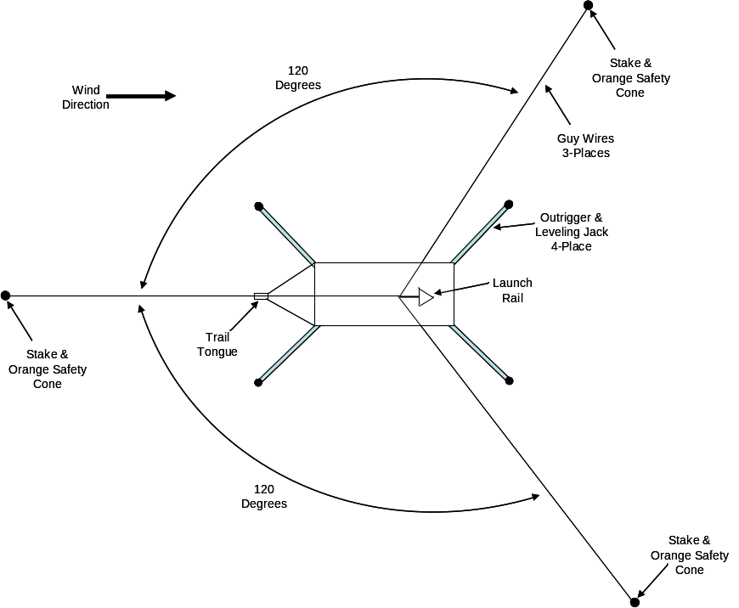
Figure 1, Mobil Launch Rail Positioning

Mobil Launch Rail Deployment Procedure
Step | Description
 | Using the tow vehicle, position launch rail such that the tow hitch is pointed in the direction of vehicle intended flight or wind direction.
Disconnect launch rail from the tow vehicle.
 | Disconnect both tow safety chains
 | Disconnect trailer lighting plug from tow vehicle.
 | Pull pin from tow ball lock.
 | Unlock tow ball.
 | Pull pin from tongue jack to unlock.
 | Rotate tongue jack to vertical.
 | Lock tongue jack by inserting pin.
 | Crank tongue jack down to lift trailer tongue up clear of trailer hitch ball.
 | Drive tow vehicle away from trailer and to the side.
Level launch rail.
 | Unstrap launch rail tower hold downs.
 | Remove the launch rail controller cable from the hand held toolbox.
 | Plug in the launch rail controller cable.
 | Turn the launch rail large power dial selector to the “A” or “B” position.
 | Raise launch rail tow approximately 10-degrees using the launch rail controller pushing the up button.
 | Unlock the spare tire cage.
 | Using two persons, one on each side, raise the spare tire cage.
 | Lock the spare tire cage in raised position. (This lock is sometimes tricky to lock.)
 | Unstow five outrigger leveling jack pads.
 | Unstow the four trailer outriggers (I-beams with leveling jacks on one end) one at a time.
 | Insert and lock outriggers in each of the four trailer corners.
 | Pin one of four pads to each of the four outrigger leveling jacks.
 | Crank each outrigger leveling jack until the launch rail is level from front to back and side to side.
 | Pin the fifth pad to the bottom of the center leveling jack just forward of the flame bucket.
 | Crank the center leveling jack until the pad is firmly on the ground.
Deploy the launch tower.
Remove the from the trailer tool box:
  - Guy wire assembly.
  - Orange safety cones.
  - Ratchet with ball hex driver.
Unstow the following from the front rack bellow the spare tire:
- Guy wire stakes.
- Sledgehammer.
 | Unlock and lower the spare tire cage using two person one on each side.
 | Lower the launch tower to the 5-degree position using the launch rail controller pushing the down button.
 | Using two people unstow each of the two tower segments.
 | Lower the launch tower to the horizontal position using the launch rail controller pushing the down button.
 | Position the tower segment that is fat on both ends near the trail tongue with its cap screws near the tongue.
 | Position the tower segment that is pointy on one end, with the cap screw end near the first tower segment end without cap screws.
 | The two tower segments should be lined up pointing in the direction of the trailer tongue.
 | Using two people lift the first tower segment up to the tower segment permanently attached to the trailer.
 | Insert the guide pins of the tower segment being held into the sockets on the permanent tower segment.
 | Using the ratchet with ball hex driver attach the four cap screws. Attach the top two first, allow the second person the let go of the tower segment when the top two are tight, and attach the bottom two cap screws.
 | Using two people lift the second tower segment up to the first tower segment now attached to the trailer.
 | Insert the guide pins of the second tower segment being held into the sockets on the first tower segment.
 | Using the ratchet with ball hex driver attach the four cap screws. Attach the top two first, allow the second person the let go of the tower segment when the top two are tight, and attach the bottom two cap screws.
Deploy guy wires.
 | Insert and pin the guy wire assembly.
 | Attach and tighten the guy wire assembly tensioning cable on the upper rail segment. Tighten until snug.
 | Uncoil the three guy wires, one in the direction of the trailer tongue, one 120-degrees to the right, and the final wire 120-degrees to the left.
 | Deploy guy wire stakes and orange safety cones to the ends of each guy wire.
 | Attach one stake to each guy wire.
 | Attach an inclinometer to the tower near the tower pivot.
 | Raise the tower to the proper angle, no less than 10-degrees from vertical, by pushing the up button on the launch rail controller and observing the inclinometer. Raise the tower using long pushes of the up button. Avoid short pushes of the button (until the tower is near its intended position) to minimize tower swaying. If swaying occurs after releasing the up button, allow it to attenuate before pushing it again.
 | Turn the launch rail large power dial selector to the “Off” position.
 | Reposition the stakes to make the guy wires taut and at their appropriate angle (straight, right 120-degrees, and left 120-degrees).
 | Using the sledgehammer, pound the stakes into the ground approximately 30-degrees to the ground or 90-degrees to the guy wire.
 | Snug the guy wires.
 | Place an orange safety cone over each stake.
Deploy flame bucket
 | Have one person lift the flame bucket.
 | Have a second person unscrew the clevis bolt on the right side and release the chain.
 | Screw that bolt back into the clevis.
 | Have that person unscrew the bolt on the left side clevis and release the chain.
 | Screw that bolt back into the clevis.
 | Have the second person grab the flame bucket.
 | Both persons lower the flame bucket to the ground while holding the flame bucket by the sides.
For high-thrust rockets:
Unstow the following from the trailer toolbox:
- Two heavy straps
- Two clevises.
- Two stakes.
 | Attach the two heavy straps to the eyes on either side of the trailer near the flame bucket using the clevises.
 | Stretch these straps straight back.
 | Stake the free end of each strap to the ground.
Loading the rocket:
 | Loosen and release the guy wires to the right and left.
 | Turn the launch rail large power dial selector to the “A” or “B” position.
 | Lower the tower until it is approximately 10-degrees above horizontal by pushing the down button of the launch rail controller.
 | Lift the rocket, carry it to the launch rail nose first, and approaching it from the flame bucket.
 | Lift the rocket high enough to engage the front launch lug with the T-rail on the top of the launch tower.
 | Adjust the rocket angle or launch rail angle such that they both match and allow the rocket to be easily slid on the launch rail.
 | Continue to slide the rocket on to the launch rail engaging each launch lug.
 | Push the rocket up the launch tower until the end of the rocket motor is clear of the bottom of the launch tower.
 | Lower the launch tower to 0-degrees from horizontal by pushing the down button of the launch rail controller.
 | Turn the launch rail large power dial selector to the “Off” position.
 | Insert rocket cradles into the launch tower structure and fasten in place to prevent the rocket from swaying back and forth.
 | Strap the rocket to the tower near one of the cradles.
 | Insert the holding bracket on the bottom end of the launch tower and insert two bolts, one on each side, to hold up the bottom end of the rocket. Make sure that the bracket is under a bottom edge of the rocket such that the rocket will not slip down when the tower is raised. Extra pieces may need to be added to the holding bracket to get it positioned under the rocket. These pieces need to be firmly attached to the holding bracket. The rocket may also need to be repositioned to insure that it is resting against the holding bracket before the tower is raised.
Preparation for launch:
 | Turn the launch rail large power dial selector to the “A” or “B” position.
 | Raise the launch rail to the desired angle using the launch rail controller up button and an inclinometer attached to the tower. Raise the tower using long pushes of the up button. Avoid short pushes of the button (until the tower is near its intended position) to minimize tower swaying. If swaying occurs after releasing the up button, allow it to attenuate before pushing it again.
 | Turn the launch rail large power dial selector to the “Off” position.
 | Reattach and snug the two guy wires to their stakes.
 | After completion of launch preparations, remove the hold down strap and supporting cradles.
Aborted launch:
 | Insert rocket cradles into the launch tower structure and fasten in place to prevent the rocket from swaying back and forth.
 | Strap the rocket to the tower near one of the cradles.
 | Loosen the right and left guy wires and detach them from their stakes.
 | Turn the launch rail large power dial selector to the “A” or “B” position.
 | Lower the launch rail to horizontal using the launch rail controller down button. Lower the tower using long pushes of the up button. Avoid short pushes of the button (until the tower is near its intended position) to minimize tower swaying. If swaying occurs after releasing the up button, allow it to attenuate before pushing it again.
 | Turn the launch rail large power dial selector to the “Off” position.
 | Unfasten the two bolts, one on each side, holding the bracket on the bottom end of the launch tower.
 | Remove the holding bracket on the bottom end of the launch tower.
 | After completion of safing procedures, remove the hold down strap and supporting cradles.
 | Turn the launch rail large power dial selector to the “A” or “B” position.
 | Raise the tower until it is approximately 10-degrees above horizontal by pushing the up button of the launch rail controller.
 | Slide the rocket of the rail.
 | Lower the tower until it is horizontal by pushing the down button of the launch rail controller.
 | Turn the launch rail large power dial selector to the “Off” position.
 | Follow the launch rail stowing procedure.

Mobil Launch Rail Stow Procedure
Step | Description
Stow high-thrust tie downs:
 | Detach heavy straps from the eyes on either side of the trailer near the flame bucket by unscrewing each clevis bolt. Screw the clevis bolts back into the clevis.
 | Coil these straps up for stowage.
 | Loosen stakes and remove from the ground using the sledgehammer.
 | Stow the following in trailer toolbox:
 | Straps
 | Stakes
Stow flame bucket
 | Have one person hold the flame bucket.
 | Have the second person unscrew the bolt from the clevis on the right side.
 | Remove the right side chain from the clevis and screw that bolt back into the clevis.
 | Have the second person unscrew the bolt from the link on the left side.
 | Remove the left side chain from the clevis and screw that bolt back into the clevis.
 | Have the second person also hold the flame bucket.
 | Have the two persons lower the flame bucket to the ground while holding the flame bucket by the sides.
Remove guy wires.
 | Remove all three orange safety cones from over each stake.
 | Loosen all three guy wires.
 | Detach all three guy wires from stakes.
 | Loosen all three stakes with sledgehammer and pull from the ground.
 | Stow the three orange safety cones in trailer toolbox.
 | Turn the launch rail large power dial selector to the “A” or “B” position.
 | Lower the tower to horizontal by pushing the down button on the launch rail controller.
 | Coil the guy wires and tie them such that they will not uncoil.
 | Loosen and detach the guy wire assembly tensioning cable.
 | Unpin and remove the guy wire assembly.
Stow the launch tower.
 | Using two people hold the end tower segment.
 | Using a ball driver ratchet, have the person closest to the joint detach the four cap screws. Loosen the bottom two cap screws first.
 | Once detached lower the tower segment to the ground.
 | Using two people hold the next tower segment.
 | Using a ball driver ratchet, have the person closest to the joint detach the four cap screws. Loosen the bottom two cap screws first.
 | Once detached lower the tower segment to the ground.
 | Raise the tower to 5-degrees from horizontal using the launch rail controller.
 | Stow the end tower segment on the right side of the trailer with the narrow end pointing to the rear of the trailer.
 | Stow the next tower segment on the left side of the trailer with the narrow end pointing to the front of the trailer.
Remove leveling jack pads and outriggers.
 | Crank all five leveling jacks all the way up.
 | Unpin and remove the five leveling jack pads.
 | Unlock and remove the four outriggers.
Stow stakes, sledgehammer, pads, outriggers, and leveling jack pads.
 | Stow the guy wire assembly in the trailer toolbox.
 | Raise the tower to 10-degrees from horizontal using the launch rail controller.
 | Unlock the spare tire basket at front of trailer.
 | Using two persons with one on each side, raise the front spare tire cage.
 | Lock the front spare tire cage in the raised position.
Stow the following in the front of the trailer bellow the spare tire cage:
Guy wire stakes.
Sledgehammer.
Five outrigger leveling jack pads.
Four outriggers.
 | Unlock the spare tire basket.
 | Using two persons with one on each side, lower the front tire basket. Make sure that sledgehammer and all stakes are retained under the metal bracket.
 | Lock front tire basket in place.
 | Lower the tower to horizontal using the launch rail controller.
 | Turn the launch rail large power dial selector to the “Off” position.
 | Unplug launch rail controller.
 | Strap the tower segments to the trailer.
Connect launch rail to the tow vehicle.
 | Crank the tongue jack up to lift trailer tongue high enough to clear of trailer hitch ball.
 | Back the tow vehicle up to the trailer.
 | Pull the pin from tow ball lock.
 | Lift lever on tow hitch lock.
 | Crank the tongue jack up to lower the trailer tongue on to the trailer hitch ball. Crack the tongue jack all the way up.
 | Pull pin on tongue jack.
 | Rotate tongue jack to horizontal position.
 | Insert the pin on tongue jack.
 | Push down lever on tow hitch lock.
 | Insert the pull pin into the tow ball lock.
 | Connect both tow safety chains to the tow vehicle.
 | Connect trailer lighting plug to tow vehicle.
 | Drive tow vehicle away with trailer attached.

Mobil Launch Rail Return Procedure
Step | Description
 | Using the tow vehicle, position launch rail such that it is positioned properly for parking.
 | Block trailer wheels (if necessary).
Disconnect launch rail from the tow vehicle.
 | Disconnect both tow safety chains
 | Disconnect trailer lighting plug from tow vehicle.
 | Pull pin from tow ball lock.
 | Unlock tow ball.
 | Pull pin from tongue jack to unlock.
 | Rotate tongue jack to vertical.
 | Lock tongue jack by inserting pin.
 | Crank tongue jack down to lift trailer tongue up clear of trailer hitch ball.
 | Drive tow vehicle away from trailer and to the side.
 | Unlock security chain from anchor point (if present).
 | Rap security chain around a solid portion of the trailer and relock (if present).

